Chapter 19, Problem 44.

Using Fig. 19.99, design a problem to help other students to better understand how to find the transmission parameters of an ac circuit.

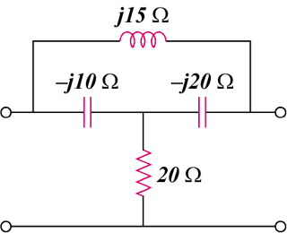
–jX_{C1}
–jX_{C2}
jX_{L}
R

Figure 19.99
For Prob. 19.44.

